**ST. XAVIER’S COLLEGE**

**(Affiliated to Tribhuvan University)**

Maitighar, Kathmandu



**Computer Graphics**

**Lab Assignment#8**

**Submitted by:**

**Shreesha Pokharel**

013BSCCSIT038

**Submitted to:**

|  |  |
| --- | --- |
| **Er. Anil K. Sah** |  |

Lecturer

Department of Computer Science

Date of submission: 8th September, 2015

**STATEMENT: IMPLEMENTATION OF REFLECTION ALONG X-AXIS AND Y-AXIS.**

Source code:

//---------------------------------------------------------------------------

#include <vcl\vcl.h>

#pragma hdrstop

#include "Unit1.h"

//---------------------------------------------------------------------------

#pragma resource "*.dfm"

TForm1 *Form1;

int x,y,a,b,i,j;

//---------------------------------------------------------------------------

__fastcall TForm1::TForm1(TComponent* Owner)

: TForm(Owner)

{

}

//---------------------------------------------------------------------------

//---------------------------------------------------------------------------

void __fastcall TForm1::Button1Click(TObject *Sender)

{

x=Image1->Height;

y=Image1->Width;

for(i=0;i<=x;i++)

{

for(j=0;j<=y;j++)

{

a=i;

b=j;

a+=x;

b+=y;

Image2->Canvas->Pixels[a][b]=Image1->Canvas->Pixels[i][j];

}

}

}

//---------------------------------------------------------------------------

//---------------------------------------------------------------------------

void __fastcall TForm1::Button2Click(TObject *Sender)

{

x=Image1->Height;

y=Image1->Width;

for(i=0;i<=x;i++)

{

for(j=0;j<=y;j++)

{

a=-i;

b=j;

a+=x;

Image2->Canvas->Pixels[a][b]=Image1->Canvas->Pixels[i][j];

}

}

}

//---------------------------------------------------------------------------

**Output:**

**Along x-axis:**

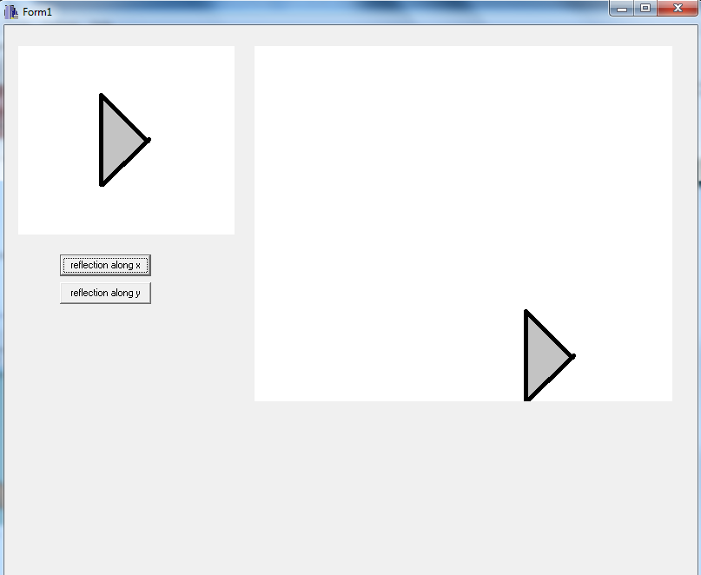

**Along y-axis:**

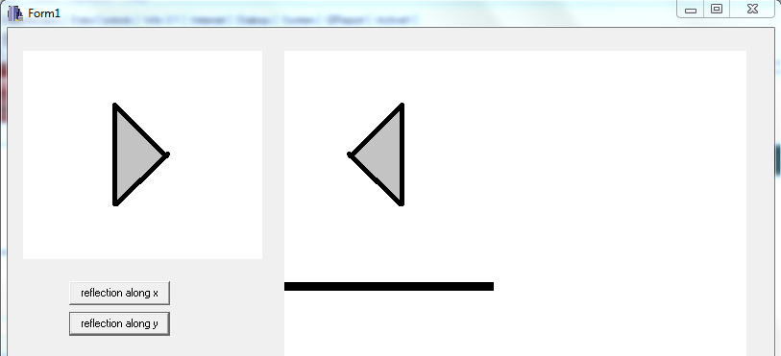

**Conclusion:**

Therefore, reflection along both X-axis and Y-axis were implemented.

**Reference:**

[1] D. Hearn and M. Baker, Computer Graphics, second edition.